Project Design Phase
Proposed Solution
Date | 8 October 2026
Student Name | OviyaShree
Project Name | Metro Ticket Generating System in ServiceNow
Maximum Marks

Proposed Solution
The proposed solution digitizes metro ticket booking using ServiceNow. A Service Catalog item collects Source, Destination, Passenger Type and Number of Tickets. Validation and auto-populate rules keep the data clean, a fare logic script calculates the fare, and a QR code digital ticket is generated instantly. Flow Designer and Notifications complete the passenger experience.
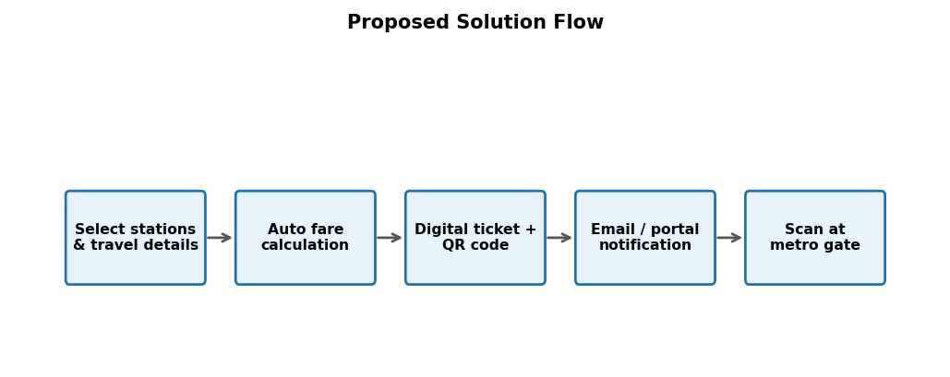
Figure 1: Proposed solution representation.
S.No. | Parameter | Description
1 | Problem Statement | Manual metro ticketing is slow, error-prone and paper-based.
2 | Idea / Solution description | Automated ticket booking with fare calculation and QR code generation in ServiceNow.
3 | Novelty / Uniqueness | Service Catalog, Flow Designer and Notifications combined with QR-based digital tickets.
4 | Social Impact / Customer Satisfaction | Shorter waits, easier access and less paper usage.
5 | Business Model / Revenue Model | Improved fare collection through digital payments (UPI, cards, wallets).
6 | Scalability of the Solution | Extendable with analytics, WhatsApp bookings and more stations.

